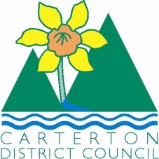

IN THE MATTER of the Sale and Supply of Alcohol Act 2012

AND

IN THE MATTER of an application by Club Carterton Incorporated for a renewal club licence pursuant to s.127 of the Act in respect of premises situated at 35-77 Broadway, Carterton known as Club Carterton Incorporated

BEFORE THE CARTERTON DISTRICT LICENSING COMMITTEE

Chairperson: Elaine Brazendale
Secretary: Colin Wright

DECISION

This is an application by Club Carterton Incorporated for a renewal club licence in respect of premises situated at 35-77 Broadway, Carterton and known as Club Carterton Incorporated.

The application was duly advertised and no objection or notice of desire to be heard has been received. Accordingly we deal with the matter on the papers.

We are satisfied as to the matters to which we must have regard as set out in s.131 of the Act and we grant the applicant a renewal club licence authorising the sale and supply of liquor for consumption on the premises, to any person who is present on the premises subject to the recommended conditions being on the Licence and including:.
Alcohol may only be sold on the following days and during the following hours:
Monday- Sunday 10.00am - 1.00am the following day and on
Anzac day- 6.00am- 1.00am the following day

DATED at Carterton this 13th day of July 2015

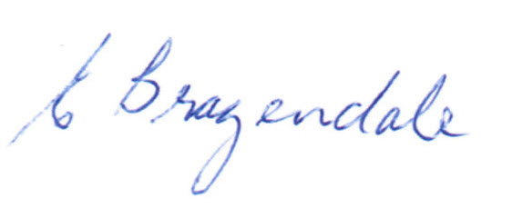
_____________________
Elaine Brazendale
Chairperson
Carterton District Licensing Committee

