

**Asset Management Plan –**

**Municipal Stormwater System**

**March 2015**

**Contents**

Quality assurance information 3

1 Introduction 4

1.1 Plan format 4

1.2 Statutory obligations 6

1.3 Corporate Goals 6

1.4 Description of Assets 7

2 Strategic environment 10

2.1 Council’s Vision 10

2.2 Statutory Requirements 10

2.3 Asset Management strategy and policy 11

2.4 Specific Strategic Direction 13

3 Levels of service 13

3.1 User Consultation and Survey 14

3.2 Target Levels of Service 14

3.3 Potential changes in Levels of Service 16

4 Growth and Demand 16

4.1 Population Demand Growth projections 16

4.2 Demand basis 17

5 Risk Assessment 18

5.1 Risk type 18

5.2 Risks to reduction of level of service 18

5.3 Statutory, financial, and management risk 19

5.4 Level of service risk mitigation actions 21

6 Life cycle management 21

6.1 Operation and Maintenance (O&M) 22

6.2 Asset Renewal 22

6.3 Asset Development 23

6.4 Description of asset management assumptions 23

6.5 Renewal Strategy 24

7 Financial Information 25

7.1 Summary of asset value 25

7.2 Financial Forecast 26

7.3 Programmed work 26

7.4 Financial conclusions 28

8 Assumptions 28

9 Improvement Actions Plan 31

9.1 Recommendations 31

10 Appendix 1 Stormwater Resource Consent 34

11 Appendix 2 Waikakariki Diversion Plan 35

Figure 1 Plan Format 5

Figure 2 Pipe material distribution 7

Figure 3 Concrete pipe size distribution 8

Figure 4 Reticulated stormwater network in Carterton 9

Figure 5 Population estimates for Carterton 17

Figure 6 Asset renewal to maintain service levels 21

Figure 7 Residual life distribution for reticulated pipes 22

## Quality assurance information

|  |  |  |
| --- | --- | --- |
| **Plan Version and Control** | | |
| **Date** | **Version No.** | **Checked by:** |
| **20th March 2015** | **Version 2** | **?** |
| **Approved for release** | | |
| **Colin Wright** | |  |
| **Prepared by** | | |
| **Andrew Duncan, EQOnz ltd** | | |

# Introduction

The purpose of this *basic* Asset Management Plan is to outline and summarise the Council’s long-term asset management approach for the provision and intergenerational management of the municipal stormwater system.

The plan describes the strategies and programmes for the Carterton municipal stormwater system adopted to meet the required level of service to existing and future users in the most sustainable and cost effective way.

The plan informs the Councils Long term Plan (LTP) and contributes to meeting the identified community outcomes. It is intended that this plan will be a live document, and that through its life it will be modified to include information and policies that improve or enhance the Council’s ability to effectively manage assets on behalf of the community.

Table 1 Purpose of Plan

|  |  |
| --- | --- |
| **Items** | **Detail** |
| **Introduction** |  |
| **Description** | Description of assets and level of service |
| **Strategic Alignment: Linkage between agreed community outcomes and Levels of Service** | Translates higher level aspirations into meaningful service level items |
| **Risk Management – assessment and mitigation against failure to deliver levels of service, with**  **mitigation measures provided e.g. projects** | Funding and associated justification. Clearly presented funding requirements, linked directly to delivering levels of service |
| **Knowledge improvement** | Improvement in data collection & application, clear lines of responsibility, and creation of a practical working document. |
| **Activity management: Prudent acquisition, operation, maintenance, renewal and disposal of assets** | Optimisation of asset use in delivering a service to the community throughout its lifecycle |
| **Financial forecasts** | Existing data is used to estimate the financial implications of the asset management |
| **Assumptions** | To communicate the assumptions used in producing this plan and therefore its limitations. |

## Plan format

The plan format is summarised in figure 1.

Section 1 Introduction

Describes the purpose and format of the plan, the strategic environment, and statutory obligations.

Plan review

Section 3 Level of service

The Levels of Service for the Municipal Stormwater activities are defined and the performance measures by which the service levels will be assessed.

Section 4 Growth & Demand

Overview of growth demand trends and the effect on the stormwater system

Section 5 Risk Management

Identifies the current state of knowledge and preferred direction for risk management of Council assets.

Section 6 Life Cycle Management

Describes the current methodology and direction of future work in optimising life cycle management.

Section 8 Assumptions

Describes the assumptions used in this plan.

Section 7 Financial Information

Compiles data from previous sections to provide budgetary guidance on fulfilling asset management obligations.

Section 2 Strategic Environment

Describes the policy and planning requirements that guide asset management planning.

Section 9 Improvement Action Plans

Describes the recommended improvement actions.

Figure 1 Plan Format

The AMP aims to put in place systems and processes that will improve the transparency and efficiency of the way that Council assets are created, maintained, and funded to meet the level of service desired by the community. This asset plan will be reviewed and revised every three years. It is recognised that enhancement of the Asset Management Plan is required over time.

The 2015 revision aims to follow the steps taken in the wastewater AMP in spatial identification of assets for the asset register. This work is underway at time of writing. Allocation of unique identifiers has been carried out, and identification of individual pipe reaches on the asset register has commenced. It is envisaged that this work will be complete by mid-2015. Spatial identification of assets is crucial for identifying repair/renewal changes to the asset register, and hence budget forecasting.

## Statutory obligations

The Carterton stormwater activity aims to provide an effective reticulated collection and environmentally sustainable disposal system for its community.

This supports community wellbeing and health values by providing a reticulation system capable of meeting the required performance targets and consent conditions.

Council has statutory obligations under the Local Government Act 2002 to continue to provide existing stormwater services and a general authority to construct public drains and undertake land drainage, recognising the requirement to take a sustainable development approach that takes into account:

* the social, economic and cultural wellbeing of people and communities; and
* the need to maintain and enhance the quality to the environment; and
* the reasonably foreseeable needs of future generations

## Corporate Goals

Carterton District—a welcoming and vibrant community, where people enjoy living.

The community outcomes (in order of priority) are:

* strong and positive leadership
* a vibrant and prosperous economy
* a safe district
* a healthy district
* a district that enjoys creativity and recreation
* a district that encourages lifelong learning
* a district that values and protects its natural environment
* a district that promotes sustainable infrastructure and services

The Council in addition has an expectation for Carterton that infill and other development as regulated by finalised draft structure plans and the Combined District Plan will generally result in growth over the timeframe of the LTP.

In addition the Council, in the future can expect to be required to consider alternative practices in regard of stormwater disposal infrastructure such as swaling, rain gardens and other flood attenuation and treatment measures.

## Description of Assets

### Reticulation

The stormwater asset consists of pipe reticulation and open drains (fig. 4). The urban area is partly serviced by this asset and in particular more recent subdivisions where infrastructure has been provided.

To be noted is the requirement that new development provides primary systems for stormwater disposal on site within the development. This requirement will over time result in more ground soakage infrastructure being acquired by Council.

There is 12.4 kilometres of piped stormwater reticulation in the urban area ranging in size from 150mm to 1200mm. Pipe types are reinforced concrete and uPVC.

There are 267 sumps and 126 manholes.

Figure 2 Pipe material distribution

Figure 3 Concrete pipe size distribution

There is approximately 6.5 km of open drain in the urban area and some 20 km in the rural area; the rural component to some extent has a dual role being part of the water race network as well.

The rural component is not included in the asset register.

### Asset Performance and Capacity

The asset as it exists is adequate to cater for most rainfall events. When localised flooding due to system overload occurs, it is generally of short term duration with only minimal impact to the urban community as evidenced by the minimal number of service requests/complaints received in relation to this activity.

### Asset Condition

The asset register records indicate the oldest pipeline to be some 40 years old. The condition is generally reflected by age but the asset is in average condition overall.

Open channel condition is a measure of the maintenance effort that is applied. In all cases, open channels are maintained according to need or on at least an annual basis.

Improvement Actions:

1. Use the GIS in coordination with a system for recording physical faults/works/repairs/replacements, the aim being to increase confidence in the data for asset condition and subsequent renewal programs. This will enhance the renewal program confidence levels.
2. Apply unique identifiers to assets on the asset register

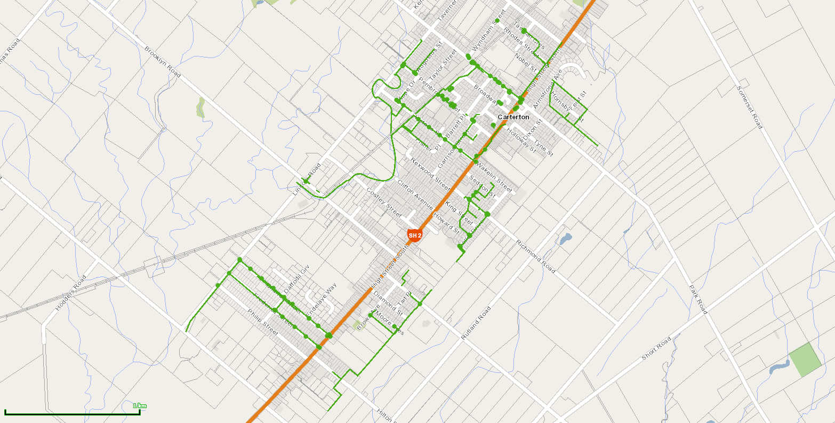

Figure 4 Reticulated stormwater network in Carterton

# Strategic environment

This section sets out the framework from which stormwater assets are managed in terms of:

* Council’s Vision
* Statutory requirements
* Asset Management Plan Strategy
* Future Demand Drivers
* Risk Issues

## Council’s Vision

Council’s vision for the future is stated as “A safe attractive and vibrant community providing and encouraging a healthy and sustainable environment.”

## Statutory Requirements

Key legislation relating to the management of stormwater assets is listed below:

● *Local Government Act 2002*. This act defines the purpose of local authorities as enabling local decision making by and on behalf of the community and allows local authorities the power of general competence. To assist exercising this power of general competence, the Act requires that significant consultation takes place with the community including:

- Council must every six years carry out a process to identify community outcomes for its district

- Council is required to consult with the community on a range of specific issues including changes to service delivery and transfer to or from Councils assets

● Resource Management Act 1991 requires Council to:

* + Sustain the potential of natural and physical resources to meet the reasonable foreseeable needs of the next generation
  + Comply with the Combined District and Regional Plans
  + To avoid , remedy or mitigate any adverse effect on the environment
  + Comply with resource consents issued by Greater Wellington Regional Council for water quality, discharges to water and land use e.g. stormwater discharges to water or land
  + Take into account the principles of the Treaty of Waitangi in exercising functions and powers under the act relating to the use, development and protection of natural and physical resources

● *Health Act 1956 and its amendments* which gives Council a general responsibility “to improve, promote and protect public health within its district.” This responsibility extends to public stormwater disposal because of the requirement to avoid unsanitary conditions from flooding.

● *Building Act 1991,* which requires every local authority to enforce the provisions of the New Zealand Building Code.

● Health and safety in Employment Act 1992

● Construction Contracts Act 2002

● The Local Government Official Information and Meetings Act 1987

## Asset Management strategy and policy

**Asset Management Policy**

The policy with respect to asset management is as follows:

• The discipline of asset management will be directed to the achievement of the Council’s Vision and Goals as stated in the LTP.

• Asset management will be applied to the long term stewardship of assets, over a minimum planning horizon of 30 years (note that the LTP planning horizon is 10 years).

• Asset management will be focused on delivering the required level of service to existing and future customers in the most cost-effective way.

• Relevant legislation, regulatory and statutory requirements will be complied with.

• A robust risk management approach consistent with good AM practice will underpin all asset management activities.

• The outputs of the asset management process will be endorsed by senior management and the Council.

• The outputs of the asset management process will be communicated to relevant staff and third parties to ensure they are aware of their asset management responsibilities.

• The asset management plan will be available to all stakeholders.

• The asset management plan will be reviewed periodically to ensure it remains relevant and consistent with the LTP.

• Senior management commit to the continuous improvement of asset management practices to achieve an alignment between the quality of asset management and the nature and scale of Council’s assets and activities. Senior management will define and implement Councils asset management staffing structure and protocols such that asset management decisions are underpinned by a continuously updated stream of relevant reporting data.

**Asset Management Strategy**

The asset management strategy to meet the policy and planning objectives is:

Levels of Service:

To maintain current levels of service, with specific, minor variations by exception, and to formally review levels of service at least every three years. Engagement with the community on satisfaction with the levels of service provided and improvements desired will be undertaken periodically. Consultation on options will be undertaken for specific, significant projects. The level of service review will inform the levels of service adopted by the Council.

Demand Forecast and Planning:

To invest in works for growth in a timely way. At present he growth rate is around 1.7% per year. Investigations are recommended to isolate and identify assets that will be reaching critical limits within the timeframe of the Plan. For most practical purposes, it is expected that population growth will not be the dominant factor the requirement for new stormwater works, and that this will be from a level of service change.

Asset Service Potential:To maintain the current service potential of the asset through an appropriate level of maintenance and renewal works.

Risk Management and Resilience:To manage risk exposure through:

− An annual review of the risk management plan and implementing risk mitigation measures where risk exposure is incompatible with corporate risk policy.

− Undertake performance and condition monitoring of critical assets

− Assess resilience of critical assets to natural hazards

− Identify and manage risks relating to natural hazards and prepare programmes to address those risks.

Optimised Decision Making:Undertake economic analysis for significant decisions related to optimisation and prioritisation of projects required to mitigate unacceptable risks.

Measure Operational Performance:Service agreements with contractors will contain performance measures consistent with the AMP and Activity Key Performance indicators (KPIs) to achieve alignment from operational level to the LTP.

Maintain and Improve Information Systems:Data collection programmes (condition, asset performance, registers and service performance) will be closely aligned to the nature and scale of the assets and to tracking achievement of service targets. Asset management system functionality will be progressively developed to meet the requirements of advanced asset management planning.

Organisational Development:To develop organisational asset management capabilities to practise advanced asset management techniques.

Regular Review:To develop the AMP as a ‘living’ document, reviewed on a regular basis to ensure alignment with current council, organisational and asset management policy and to submit AMPs for formal adoption by the Council.

Continuous Improvement:To improve AM practices, processes, systems and plans in accordance with the improvement plan which will be reviewed annually.

Monitoring of Levels of Service Performance Measures:Monitor performance measures on a monthly basis and report to City Networks management team.

## Specific Strategic Direction

The existing stormwater consent (Appendix 1) is due to expire in 2016. The Draft Natural Resources Plan (DNRP) signifies a significant shift towards management of stormwater, including potential requirements for detention and treatment of stormwater.

A key requirement of the DNRP is the development of a Stormwater Strategy; this will likely be the focus over the next AMP period, and will guide level of service requirements.

Improvement Actions:

Commence work on scoping a stormwater management plan. This might give an early ‘heads up’ as to issues and options to meet regulatory requirements over the next few years.

In conjunction with the Stormwater strategy should be a 3 waters strategy. There are significant overlaps and synergies between the 3 waters and this needs to be recognized and acted upon. For example policies promoting domestic rainwater harvesting would reduce freshwater consumption as well as stormwater generation. There are many such links that need to be considered in the development of individual water strategies.

# Levels of service

This section defines the Levels of Service or the qualities of the service that Council intends to deliver and the measures to monitor if this is achieved. The adopted levels of service will support Council strategic goals and are based on user expectations, statutory requirements and tailored to the scale and relative simplicity of Council’s asset.

The adopted levels of service also reflect the level of funding that is required to maintain, renew and upgrade the water infrastructure to provide the users with the adopted levels of service.

Levels of Service have been based on:

● User Consultation and Survey

● Strategic and Corporate Goals

● Statutory requirements and Environmental Standards

● Community Outcomes

## User Consultation and Survey

The latest community survey summary, released August 2014 by Communitrak.

In respect of stormwater services, the satisfaction measure for reporting purposes was 73% of those surveyed with a minor drop due to a change in more respondents unable to comment compared to the 2011 survey.



## Target Levels of Service

1. Community Outcomes

Monitoring of performance standards is an integral part of service management. Regulatory changes to performance standards (2013) has required realignment of Councils monitoring and reporting in order to meet regulatory requirements. The first set of performance data under these new measures will be not be available until post July 2015.

| **The service broken down into measurable components** | **Performance measure** | **Target for year ending June** | | | | | **Measuring system** |
| --- | --- | --- | --- | --- | --- | --- | --- |
| **2015**  **Annual Plan** | **2016** | **2017** | **2018** | **2019 to**  **2025** |
| Urban stormwater is managed at the best possible cost for the required level of service | Expenditure is within approved budget | 100% | 100% | 100% | 100% | 100% | Regular financial reporting to the Council |
| ~~Response to service requests~~ | ~~Significant reticulation blockages cleared within 4 hours during storm events~~ | ~~na~~ | ~~100%~~ | ~~100%~~ | ~~100%~~ | ~~100%~~ | ~~Operational records~~ |
| ~~Stormwater system of a standard satisfactory to residents~~ | ~~Urban residents satisfied with the stormwater system~~ | ~~≥70%~~ | ~~≥79%~~ | ~~≥79%~~ | ~~≥79%~~ | ~~≥79%~~ | ~~Survey of residents every three years[1]~~ |
| ~~The urban stormwater service is managed in a sustainable manner~~ | ~~Compliance with resource consent conditions including discharge requirements~~ | ~~100%~~ | ~~100%~~ | ~~100%~~ | ~~100%~~ | ~~100%~~ | ~~Resource consent~~ |
| System and adequacy | Number of flooding events[2] | na | ≤1 | ≤1 | ≤1 | ≤1 | Operational records |
| For each flooding event, the number of habitable floors affected, per 1000 properties connected. | na | ≤1 | ≤1 | ≤1 | ≤1 | Operational records |
| Management of environmental impacts | Number of abatement notices | na | 0 | 0 | 0 | 0 | Operational records |
| Number of infringement notices | na | 0 | 0 | 0 | 0 | Operational records |
| Number of enforcement orders | na | 0 | 0 | 0 | 0 | Operational records |
| Number of successful prosecutions | na | 0 | 0 | 0 | 0 | Operational records |
| Response to stormwater system issues | The median response time[3] to attend a flooding event | na | ≤180 mins | ≤180 mins | ≤180 mins | ≤180 mins | Operational records |
| Customer satisfaction | Total number of complaints[4] received per 1000 properties connected | na | ≤10 | ≤10 | ≤10 | ≤10 | Operational records |

Table 2 stormwater contribution to community outcomes

## Potential changes in Levels of Service

The planned modification of the Waikakariki stream will signify a change in level of service by reduced flooding potential. This has been long identified and is budgeted to occur 2015/2016.

The most significant item in terms of level of service is the likely future legislative requirements of the Draft Natural Resource Plan. Whilst not yet of any legal effect, the Plan is highly likely to require greater planning, control, and mitigation of effects from stormwater generation and disposal.

Improvement Actions:

1. Develop a stormwater management plan

# Growth and Demand

## Population Demand Growth projections

The Carterton district, usually resident, population increased from 6,849 in 2001 to 8,235 in 2013, an overall increase of 20%, and an average annual increase of 1.7% per annum. At the current rate of uptake of zoned residential land, it is estimated that within the planning timeframe (2030) there will be a capacity shortfall for future greenfield development. To grow the town, Council will therefore need to develop strategies to overcome this shortfall, either by re-zoning of surrounding land, or by promoting more intensive development within the current town boundaries. Either option will have implications in terms of the stormwater assets.

Any such new stormwater assets would likely need to meet different service levels to the existing infrastructure.

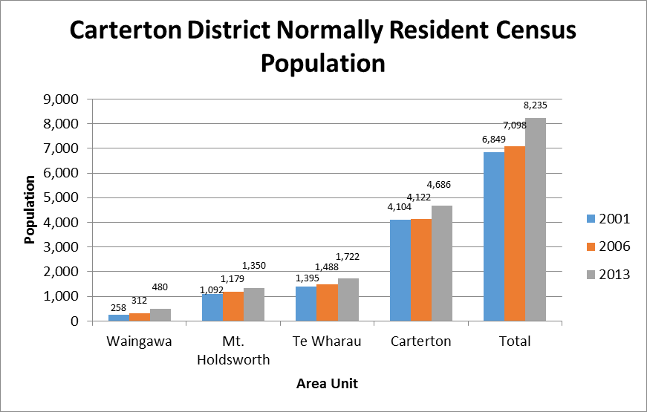

Figure 5 Population estimates for Carterton

No significant demand changes are planned in terms of type of use or significant commercial/industrial additions. The predicted demand growth is related to primarily additional road construction from new urban areas, and the possible increase in intensity of rainfall events.

## Demand basis

### Quantitative

Stormwater services are somewhat different to other Council services in that the generation of stormwater is dominated by meteorological conditions, and hence particularly susceptible to cyclical weather patterns and climate change.

Climate change predictions suggest that there is a likelihood of increase in the number of extreme rainfall events. This clearly has an effect on the stormwater system, as there is finite flow capacity for any particular aspect of the system.

In addition, secondary flow paths are activated when primary disposal mechanisms cannot cope, and it is reasonably foreseeable that an additional load on the reticulated system could occur due to capacity of individual systems being insufficient to meet the new demands initiated by a changing climate.

Council employed Worley consultants in 1992 to investigate and produce a stormwater management plan. It is unclear which elements of this plan have been adopted, and which elements are still applicable. It is recommended that a review of this original plan be carried out to a) assess its currency, and b) to extract information on system capacity that can be added to the GIS & asset register to paint the picture of the system capacity. This would also assist in informing the asset management strategy.

### Qualitative

In addition to the quantitative demands placed on the stormwater system, there is also an issue of stormwater quality: as stormwater flows over land it can pick up, and carry in suspension, particles of soil, metal, rubber or other contaminants from roads or roofs.

Whilst historically these issues have not received scrutiny there is increasing pressure to ensure that the stormwater discharged is of suitable quality for the receiving environment to assimilate any contaminants. Thus it is foreseeable that during the term of this plan (most likely at the expiry of the current resource consent), there could be a change in service level required. This is therefore a budget risk item.

# Risk Assessment

Risk Management processes aim to be generally consistent with the intentions of AS/NZS 4360: 2004 “Risk Management” Standard however of a scale appropriate to the asset.

## Risk type

Risk is divided into two broad categories:

* level of service risks, and
* statutory, financial, and management risk

## Risks to reduction of level of service

It has been identified that risk management in previous Asset Management Plan needs improvement. The 2012 revision set a base level to which further work can be added and refined. It identifies ‘grass roots’ level risks and risk management approaches that have been adopted to date, but only informally described or detailed. Renewal strategies are addressed in Section 6.5. No progress has been made on this front since 2012.

|  |  |  |
| --- | --- | --- |
| **Key risks** | **Service/asset related impact of changes** | **Risk mitigation strategies** |
| **Climate variability** | Climate change induced variability in rainfall patterns and hence stormwater and surface flows, is clearly a potential risk for stormwater treatment and environmental effect changes.  It is becoming increasingly clear that climate variability is becoming reality sooner than notionally anticipated. | Climate change induced risks need to be more fully understood, and more detailed work in this area would be beneficial during the term of this plan. |
| **Identification of assets’ relative importance** | Decision making in terms of asset renewal needs prioritisation to optimise the process. Whilst asset vulnerability is a key part, the relative criticality of assets throughout the network is also important. | An initial estimate of asset importance needs to be made during the life of this plan to assist prioritisation decisions. |
| **Consent renewal 2016** | Monitoring and treatment of discharge could be required under a new consent. | Budget allowance for investigation work. |

## Statutory, financial, and management risk

In the context of statutory, financial, and management risk, Carterton’s risk management mitigation criteria are based around goals of:

● The fulfilment of legal and statutory obligations

● The safeguarding of public and employee’s Health and Safety requirements

● Asset, 3rd Party Property Damage & Losses Insurances

● Contingency Planning for foreseeable emergency situations

Hence appropriate to the scale of Carterton’s activity, probability and impact management of these risks is tabulated as follows;

|  |  |  |  |  |
| --- | --- | --- | --- | --- |
| **Risk Type** | **Typical Events** | **Risk Probability** | **Impact** | **How Managed** |
| Legal and Statutory | Discharge Consent breach  Environmental Damage | Low  Low | Low  Low | Regular monitoring and reporting. Instigate investigations to inform the next consent application. |
| Health and Safety | Infectious Disease outbreak from flood waters | Low | High | Notification to relevant authorities |
| 3rd Party Property Damage Liability | Inundation, damage from failed pipelines | Moderate | Med/High | Routine maintenance procedures and insurance cover, plus investigation into climate change issues. |
| Service Delivery Failure | Service Restoration, failure to meet KPI’s  Asset condition failure  Unforeseen natural disaster resulting in loss of infrastructure | Moderate  Low  Low | Low/Med  Low  High | Manage by routine procedures  Active Replacement Programme based on acquired knowledge. Identify critical assets, and develop mitigation/redundancy/alternative service strategies.  Regional Civil Defence and in house emergency management plans. |
| Financial | Un-planned loss or cost to reinstate infrastructure | Low | High | Adequate Disaster Insurance in place |
| Contingency Planning | Supplementary measures/ actions to ensure continuity of treatment and disposal e.g. due to meteorological conditions | Moderate | Medium | Plan for controlled reactions to increasing levels of stress from meteorological conditions. |

## Level of service risk mitigation actions

The risk mitigation actions taken to ensure continuity of service are to identify critical paths in the stormwater system, and to develop management plans for situations where stormwater flows exceed system capability.

Improvement Actions:

1. Carry out sampling of stormwater to ascertain potential treatment requirements
2. Define criticality of stormwater assets
3. Review the 1992 stormwater management plan for current applicability and identification of system capacity

# Life cycle management

An asset’s useful life cycle is finite in time terms and depending on type can range from ten to one hundred years depending on the nature of the asset.

Capital expenditure

Depreciation funding

Rates

Asset maintenance

End of service life

Asset installation

Level of service

Figure 6 Asset renewal to maintain service levels

Successful life cycle management encompasses the adoption of appropriate:

* Target Levels of Service
* Risk Management systems
* Demand Management Regimes
* Routine operations and maintenance plan
* Asset renewal programmes
* Asset Improvement Programmes
* Levels of Funding

## Operation and Maintenance (O&M)

The O&M strategy aims to generally retain the current levels of service by implementing a balanced programme of planned and reactive works for the stormwater reticulation.

## Asset Renewal

It is proposed to, during the currency of this AMP and beyond, to obtain condition information so that a rolling programme of renewal work can be devised and funded.

Whilst assets have a notional life expectancy, the actual life can vary. By understanding the variability inherent in asset life, appropriate funding and risk scenarios can be adopted. For the stormwater assets, this is yet to play a significant part in asset management, as the assets are all at or below half way through their useful life (fig. 7), however condition rating is a useful tool to mitigate against unexpected budget requirements.



Figure 7 Residual life distribution for reticulated pipes

This 2015 Asset Management Plan aims to strengthen the causal links between asset condition, planning, and funding mechanisms.

There is a balance between the cost of investigative work and variability inherent in assessments that are based on information that is more anecdotal. As better data is collected, more refined life expectancies may be achievable, which would in turn increase the accuracy of the renewal predictions.

Theoretical asset renewal dates have been colour coded to give a visual indication of relative end-of–service for each asset. This information is then distilled into financial budget information in section 7.

## Asset Development

### Waikakariki drain

Improvements to the Waikakariki drain are planned, to improve the efficiency of the stormwater system (Appendix 2).

### Consent requirements

In order to meet increased environmental demands, asset development may be required at the next consent. The likelihood of this risk eventuating is unknown, and cannot be predicted without some knowledge of the stormwater contaminant load.

## Description of asset management assumptions

Assumptions in the preparation of this Water Asset Management Plan include:

That stormwater assets will remain in Council ownership through out the planning period (10 years) and that there will be an ongoing requirement for this activity.

All new subdivision applications are assessed in accordance with the current District Plan and the New Zealand Standard NZS 4404:2004, “Land Development and Subdivision Engineering”. All designs are in accordance with the standards, they are checked and agreed to by Council’s engineers before construction commences and are inspected during construction, including witnessing of the relevant tests. The developer is expected to meet all costs of the works including the connection to Council’s existing network

Whilst the demand upon this activity will increase due to anticipated growth (primarily from the run-off from new roads), the operational requirements for this activity will remain similar for the next ten years.

Maintenance works will continue to be delivered by Council’s Works Department staff, while renewal, upgrade and new works will normally be completed by contractors selected by competitive tender or day work rates.

Funding will be required to provide for renewal as described elsewhere in this Asset Management Plan. That funding of maintenance and renewal works will be by annual rates charges and depreciation, while funding for capital works will generally be from loans and development contributions as appropriate.

Asset values will be re-adjusted at each plan revision to give a current overall asset value.

Financial and future work forecasts are based on the currently available knowledge of asset condition and performance, to the levels of service that have been undertaken to be delivered. More detailed evaluation of asset renewal requirements will be undertaken in the near future to identify programmes of work.

## Renewal Strategy

The renewals approach has been refined to incorporate consideration of criticality and vulnerability in decision making, and utilises asset maintenance history and condition. ***In practice, with a relatively small infrastructure such as Carterton’s, decision making has historically been straightforward, and has not required detailed assessment.*** However if, and when, multiple renewals are necessary and compete against budget constraints, a more formal process is required to prioritise the renewal choices.

Criticality and vulnerability should underpin the renewal decision making process. Criticality or the consequence of failure is a practical assessment of the economic, social, cultural and environmental drivers related to asset components. Vulnerability incorporates the probability of failure due to naturally occurring conditions. Work on this has been deferred since 2012.

### Asset prioritisation

For stormwater assets renewal prioritisation, when required, will be assessed by combining the importance rating and condition rating as below. There are no stormwater assets currently considered lifeline assets.

Table 8 Asset importance rating

|  |  |
| --- | --- |
| **Importance rating** | **Description** |
| **1** | Not important. Assets for which no specific criticality assessment has been carried out. Assets servicing minor demand areas, with multiple redundancy or service options. |
| **2** | Assets of some importance. Assets servicing moderate demand areas with redundancy or multiple service options. |
| **3** | Important assets. Assets servicing moderate demand areas with difficult or costly alternative service options. |
| **4** | Very important assets. Assets servicing significant areas with difficult or costly alternative service options. |
| **5** | Essential or extremely important assets. Assets servicing significant areas with no redundancy or alternative service options. |

Table 9 Non-lifeline asset condition rating in terms of likelihood of failure

|  |  |
| --- | --- |
| **Condition rating** | **Description** |
| **A** | Failure very unlikely to occur within a year |
| **B** | Failure unlikely to occur within a year |
| **C** | Failure possible within a year |
| **D** | Failure likely to occur within a year |
| **E** | Failure has occurred/almost certain to occur within a year |

Table 10 Non-lifeline asset priority matrix for renewal

|  |  |  |  |  |  |
| --- | --- | --- | --- | --- | --- |
|  | **Importance rating** | | | | |
| **Condition rating** | **1** | **2** | **3** | **4** | **5** |
| **E** | L | M | H | VH | VH |
| **D** | L | M | M | H | VH |
| **C** | L | L | M | M | H |
| **B** | L | L | L | M | H |
| **A** | L | L | L | L | M |

Legend:

VH Very high priority

H High priority

M Moderate priority

L Low priority

Improvement Actions:

1. Apply unique identifiers to all stormwater assets
2. Update asset register to include identifiers for all assets
3. Collection of renewal/repair and servicing data is currently fragmented. There need to be positive (formal) links between asset modifications and the asset register. This should be defined by the Asset Management Policy.
4. Define asset criticality

# Financial Information

## Summary of asset value

Re-valuation of the infrastructural assets relevant to this activity was undertaken in 2014 by Opus International Consultants Ltd (valuation as at 30th June 2013).

Replacement cost is the cost of re-building the existing asset to an equivalent level of service. The assets have been depreciated on a straight line basis over the economic life of the asset.

Table 11 Summary of network value

|  |  |  |  |
| --- | --- | --- | --- |
| Network  component | Optimised replacement cost  ($) | Optimised depreciated replacement cost  ($) | Annual depreciation  ($) |
| Reticulation | 5,383,675 | 3,376,974 | 54,998 |
| Open drains | 219,027 | 162,282 | 1,095 |
| Manholes | 390,638 | 249,414 | 3,906 |
| Sumps | 243,953 | 150,629 | 2,568 |
| Soak pit chambers | 16,984 | 15,795 | 170 |
| Total | **$6,254,280** | **$3,955,094** | **$62,737** |

## Financial Forecast

Information from Section 6 has been used to identify renewal costs based on theoretical asset life, ***however given the relatively recent installation of stormwater pipes (compared to the water or sewerage networks), there are no forecast renewals necessary within the period of the plan.***

The budget forecast is therefore related solely to depreciation and maintenance items.

## Programmed work



Table 12 Capital works programme

## Financial conclusions

* The base life asset renewal forecast suggests that the current depreciation funding adequately covers budget risks for this period.
* The expiry of the discharge consent within this period adds a budget risk in terms of possible increased level of service. The level of this budget risk cannot be predicted with any confidence.
* Costs shown are 2014/2015 prices, and actual budget needs to consider inflation costs.

# Assumptions

Assumptions in the preparation of this Stormwater Asset Management Plan include:

That stormwater assets will remain in Council ownership throughout the planning period (10 years) and that there will be an ongoing requirement for this activity.

All new subdivision applications are assessed in accordance with the current District Plan and the New Zealand Standard NZS 4404:2010, “Land Development and Subdivision Engineering”. All designs are in accordance with the standards, they are checked and agreed to by Council’s engineers before construction commences and are inspected during construction, including witnessing of the relevant tests. The developer is expected to meet all costs of the works including the connection to Council’s existing network

Whilst the demand upon this activity will increase due to anticipated growth (which cannot be quantified) the operational requirements for this activity will remain similar for the next ten years.

Maintenance works will continue to be delivered by Council’s Works Department staff, while renewal, upgrade and new works will normally be completed by contractors selected by competitive tender or day work rates.

Funding will be required to provide for renewal as described elsewhere in this Asset Management Plan. That funding of maintenance and renewal works will be by annual rates charges and depreciation, while funding for capital works will generally be from loans and development contributions as appropriate.

Asset values will be re-adjusted at each plan revision to give a current overall asset value.

Financial and future work forecasts are based on the currently available knowledge of asset condition and performance, to the levels of service that have been undertaken to be delivered. More detailed evaluation of asset renewal requirements will be undertaken in the near future to identify programmes of work.

The following basic assumptions have been made in preparing 30 year funding requirement forecasts:

* All expenditure is stated in dollar values as at 30 June 2014 with no allowance made for inflation over each subsequent year of the 30 year planning period.
* No significant increase in overhead costs will occur during the 2015-2045 planning period.
* Operational cost will increase with upgrades at plants required to meet higher levels of final effluent quality required
* It is anticipated that there will be a gradual but continual increase in operation and maintenance expenditure in real terms over the planned period due to ever more stringent compliance requirements leading to higher compliance costs and the continued ageing of the asset. A small part may be offset by improved asset management decision making made possible by enhanced information used in asset management systems
* Improved asset renewal decision making is expected to reduce maintenance needs made possible by enhanced information used in the asset management system which should help to slow the rise in operating cost. As this reduction is difficult to quantify, it has been assumed that the net effect will be neutral and has not been provided for in the financial forecast.
* There will be no additional assets vested in Council from subdivisional development over the term of the AMP. This assumption will be reviewed in the next 3 year planning cycle
* Programmed renewal works are expected to result in reduced cost of maintenance over time. As this possible reduction is difficult to quantify it has not been allowed for in the financial forecasts.
* Maintenance allocations are based on maintaining current levels of service including compliance with current resource consents.
* Significant increases in the renewal funding may result from more detailed evaluation of assets.
* Changes in the district population will not have material impact on the expenditure forecasts for the stormwater schemes over the 2015-44 period
* Significant increases in the funding requirement may result from more detailed evaluation of asset renewal requirements and the need to meet higher resource consent standards

These assumptions and the AMP will be reviewed in 2017 in light of improved asset information that will be collected and recorded over the next 3 years ahead of the 2018-28 LTP.

The system is comprised of components ranging in age from 1 to 40 years, with differing levels of confidence in the material type, age, and condition. The NAMS confidence grades are used:

|  |  |  |
| --- | --- | --- |
| **Data Confidence** | | |
| Grade | Description | Accuracy |
| 1  2  3  4  5 | Accurate  Minor inaccuracies  50% estimated  Significant data estimated  All data estimated | 100%  +/- 5%  +/- 20%  +/- 30%  +/- 40% |
|  |  |  |

These are then applied to the stormwater assets as follows:

|  |  |
| --- | --- |
| Asset Type | Carterton District Council Data Confidence grade |
| Reticulation pipe age | 2 |
| Reticulation pipe material | 2 |
| Reticulation pipe condition | 5 |
| Open Channel condition | 1 |

|  |  |
| --- | --- |
| **Forecast confidence rating** | |
| Confidence Grade | General meaning |
| A Highly reliable | Data based on sound records, procedure, investigations and analysis, documented properly and recognized as the best method of assessment. |
| B Reliable | Data based on sound records, procedures, investigations and analysis, documented properly but has minor shortcomings, for example the data are old, some documentation is missing, and reliance is placed on unconfirmed reports or some extrapolation. |
| C Uncertain | Data based on sound records, procedures, investigations and analysis which is incomplete or unsupported, or extrapolated from a limited sample for which grade A or B data is available. |
| D Very uncertain | Data based on unconfirmed verbal reports and/or cursory inspection and analysis. |

|  |  |
| --- | --- |
| Asset Type | Forecast confidence rating |
| Pipe reticulation | B |
| Manholes | B |

# Improvement Actions Plan

## Recommendations

The following are recommendations for refining Asset Management Plan data and budget forecasting:

|  |  |  |
| --- | --- | --- |
| Action | Responsibility | Completion Date |
| Adoption of the asset management policy noted in this document or variation thereof. Appoint or delegate a position of asset manager. | Senior management | July 2015 |
| Put systems in place to ensure that assets that have been replaced are removed from the asset register. | Asset manager | October 2015 |
| Put systems in place to ensure that the construction date used for assets is updated on the asset register as renewals are made. This will largely be achieved by having unique identifiers for all stormwater assets. | Asset manager | July 2015 |
| Put systems in place to ensure the effective capture of renewal/maintenance/condition data. | Senior management/Asset manager/ Operations staff | October 2015 |
| Ensure that assets that have both capital and maintenance aspects are adequately reflected in the asset register. Each item needs its own register inclusion or minor assets that are more realistically operational items should be removed from the register. | Asset manager and operations staff | Dec 2015 |
| Review/update GIS data to include the pipe location by street: this is how pipe assets are replaced, and so should be reflected on the asset register. In addition different pipes may have different condition rating depending on location (e.g. in the verge vs in the road). | GIS operator/Asset manager | May 2015 |
| The methodology adopted in section 6 should be applied in the near future to develop a critical asset register, and investigations undertaken to report on the condition, possible risk mitigation measures, and alternative service/redundancy strategies in case of damage from significant natural events. | Asset manager | October 2015 |
| Further work on identification of climate change risks specific to the area should be undertaken. This would largely be sourced through existing government research, but applied to the Carterton District. This could also involve a secondary flowpath strategy for the town to mitigate flood damage in extreme rainfall events. | Project team | July 2016 |
| Assessment of the effects of Carterton District Council stormwater discharges should be carried out to provide a basis on which to make judgements and to substantiate future resource consent applications. | Project team | October 2015 |
| Identify and develop a contingency plan (as per resource consent requirement) to mitigate the effects of hazardous chemical spills in the catchment, and to qualify the budgetary risk associated with this item. | Project Team | October 2015 |

# Appendix 1 Stormwater Resource Consent

# Appendix 2 Waikakariki Diversion Plan

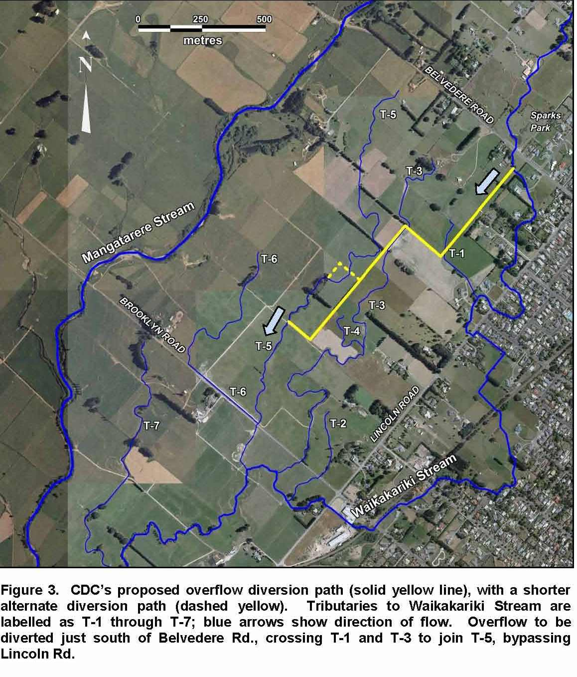

# Appendix 3 Worley Stormwater Management Plan 1992

1. *NRB CommunitrakTM Survey*—every 3 years. The next survey is planned for 2017.
2. an overflow of stormwater from the Council’s stormwater system that enters a habitable floor
3. measured from the time that the Council receives notification to the time that service personnel reach the site
4. total number of complaints received about: sewage odour; sewerage system faults; sewerage system blockages; and the Council’s response to issues with its sewerage system, expressed per 1000 connections to the territorial authority’s sewerage system.